CSA1413 - COMPILER DESIGN

1. integer to float
#include <stdio.h>
int main() {
int a=10;
float b;
b=(float)a;
printf("integer value = %d \n", a);
printf("float value = %.2f", b);
return 0;
}
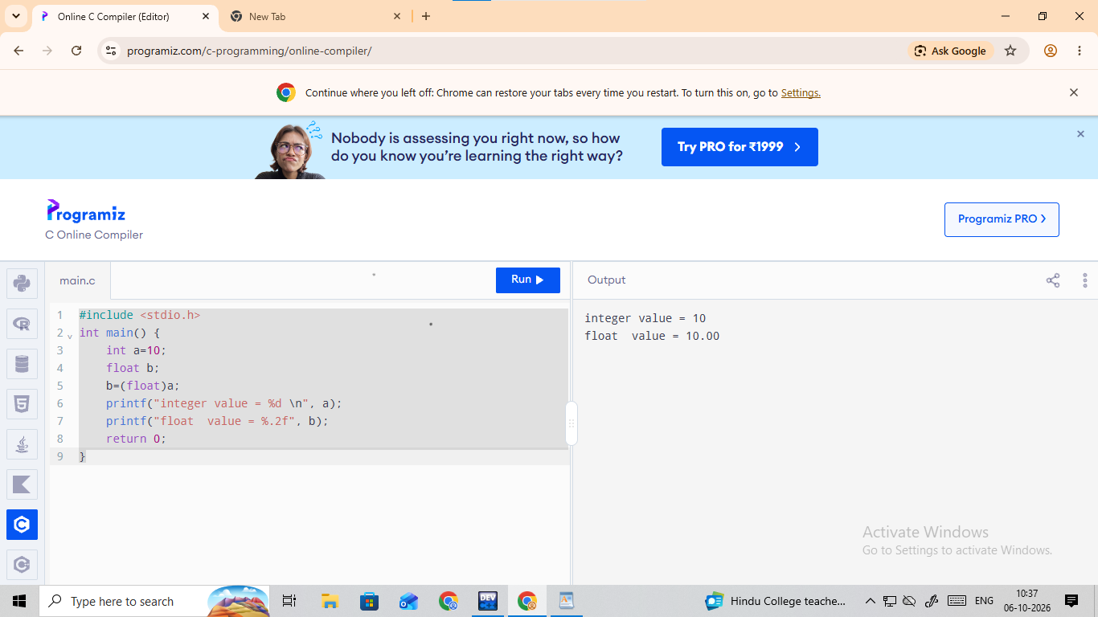

2. Float to Integer

#include <stdio.h>
int main()
{
float a=10;
int b;
b=( int)a;
printf("float value = %.2f \n", a);
printf("integer value = %d", b);
return 0;
}


